EMG Stats Analysis

Here I am going to look at the EMG stats now, as we look at the Mean%, Peak Absolute%, and Variability%.

# Box Plots of Muscle Joints

* 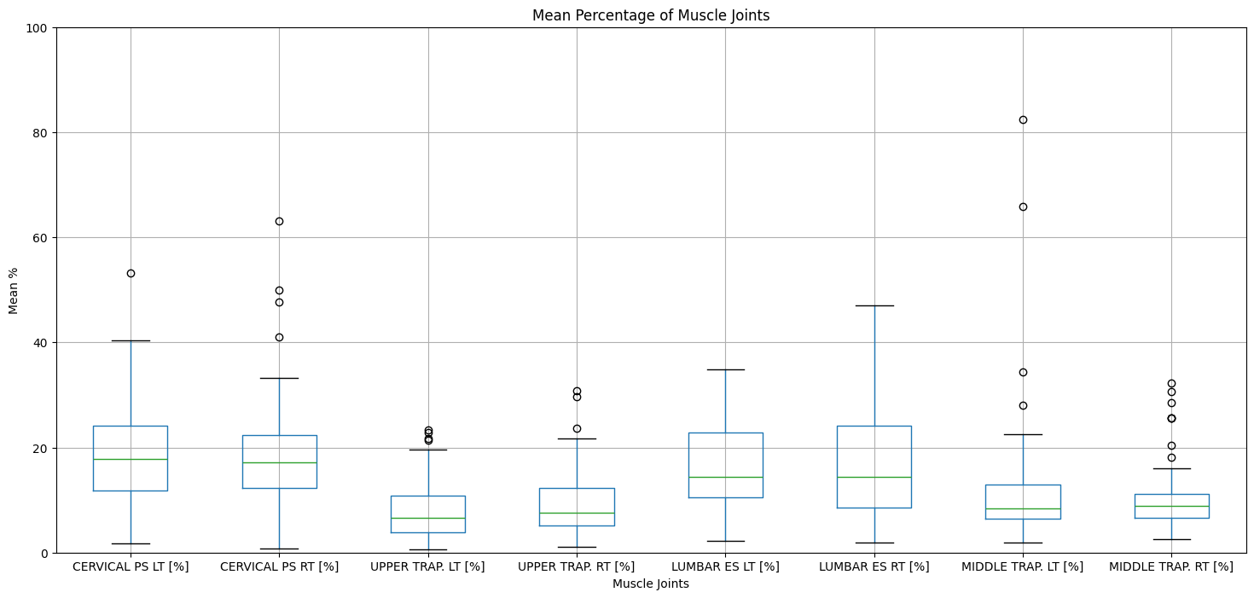
  + There is an outlier of about 450 percent for case 2 subject 008.
* 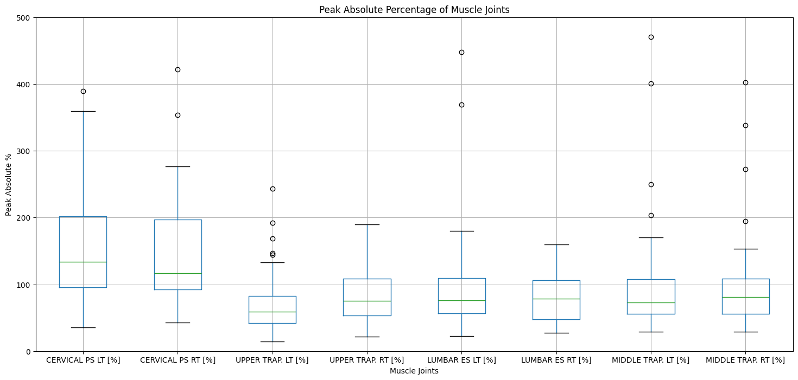
  + There are some major outliers of 62,000 percent in peak absolute for case 2 subject 008.
* 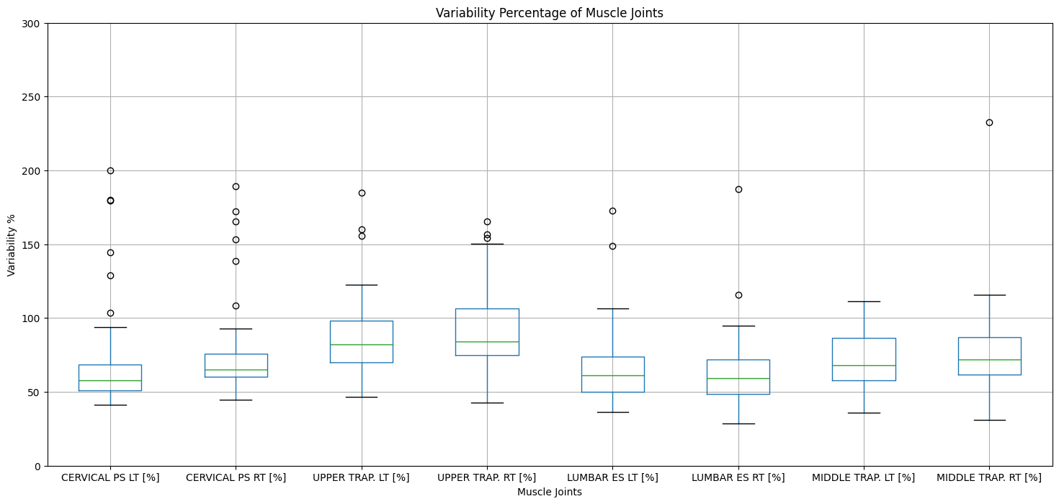
  + Once again a major outlier related to the data of subject 008 for case 2.

# Correlation Matrices

* 
 